**Project Diagram**

User can deploy the blueprint – AS3 & TS at <https://udf.f5.com/d/841a8f72-9c6a-45ad-82c5-c9be75ed0bfe#documentation>

Login to Windows server 2016 with administrator : DQ7Zgatc1Mw

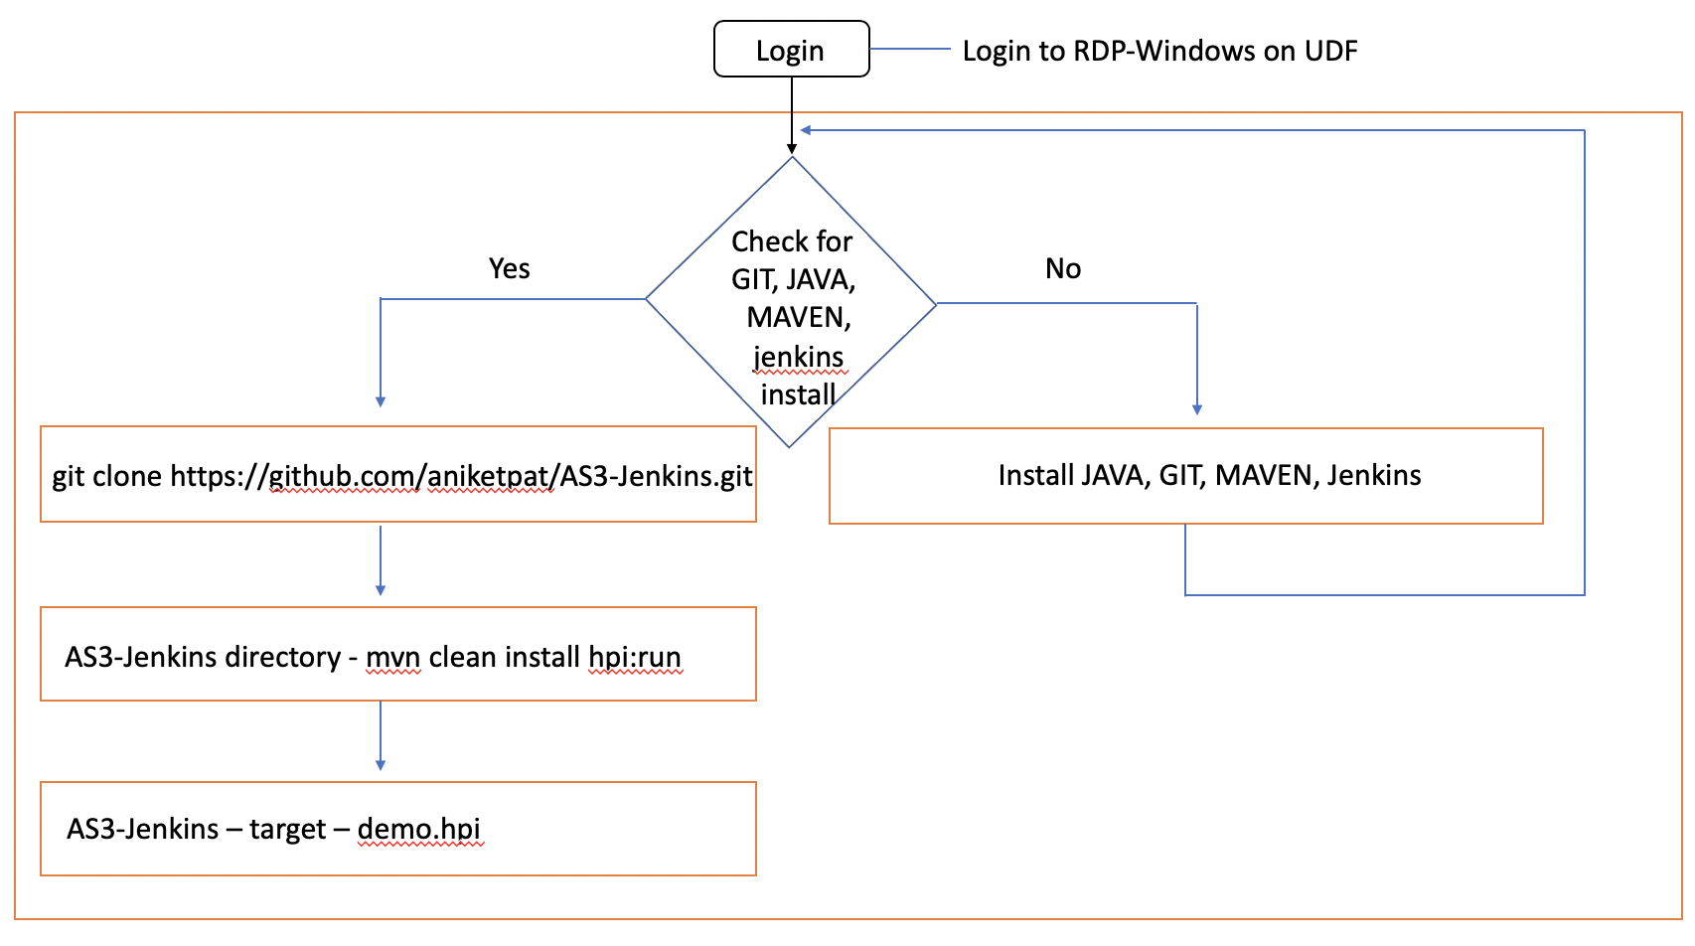

Phase I Diagram:

Phase II Diagram:

